What does the Czech data tell us?
All data references in my KCOR or Czech github.

Executive summary
- The COVID vaccine benefit appears to have been a “mirage” created by selection bias caused by static HVE and non-proportional hazards (NPH). The unvaccinated have higher mortality and frailty and, because of that, disproportionately higher COVID rates. We show their mortality rates during COVID were caused by their mortality differences, not their vaccination status.
- Many methods show vaccine harm. Given retrospective record-level vaccine data, KCOR is the most accurate objective analysis method that consistently shows statistically significant harm >> benefit by the end of 2022.

NPH caused additional α≈0.163 harm
I looked at pre-vaccine COVID mortality rates for full population cohorts of different ages relative to baseline mortality rates of the same FULL cohort (regardless of vaccination status).

I found that during COVID waves, ACM mortality did NOT scale linearly with baseline mortality, i.e., COVID was a non-proportional hazard (NPH).

The best estimate is to compute the mortality ratio between the cohorts and then multiply by an additional factor of ratio^.163.

α (the exponent) was estimated from four pre-vax age bands (1930–1960); bootstrapped 95 % CI = 0.106–0.223. Using any value within this range leaves ε≈1 (where ε = 1 means no benefit).. Details in KCOR_CMR_analysis:NPH estimate. There are other ways that get a higher value that I haven’t yet evaluated; this was my first try and it was sufficient to make my point.

For example, this means people with a 3X all cause mortality rate would be expected to produce a 3.6 higher COVID mortality, rather than a 3X higher COVID mortality.

COVID is unusual in this respect. Most viruses are proportional hazards (mortality proportional to underlying mortality).

This is a large and significant effect and it cannot be ignored.

HVE created a 3x h(t) differential between cohorts of the same age
When dealing with vaccinated vs. unvaccinated cohorts, there is a “static” healthy vaccinee effect that is typically around a 3X difference in mortality just after vaccination, consistent with other studies.

The unvaccinated cohort has both higher average mortality and frailty (these are orthogonal terms in the Gompertz mortality model).

Because the unvaccinated cohort is more heterogeneous and includes a greater share of frail individuals, it has a wider distribution of baseline hazards. If only the most frail die of COVID, that heterogeneity alone can make the vaccine appear to provide a large benefit, even when the biological effect is nil.

This is precisely why KCOR incorporates a slope normalization step which is highly unusual in epidemiological studies since those studies rarely deal properly with vaccinated / unvaccinated cohorts (invariably believing that Cox PH and other methods are appropriate which they can’t be because they don’t deal with the known complexities created by HVE).

In the Czech case, it is easy to validate a 3X baseline mortality difference created by the decision to vaccinate or not as shown in KCOR_CMR_analysis: 2021-24 3x static HVE tab which shows for fixed cohorts (born in 194x) the mortality rates of the cohorts (2,000 for Dose 2 vs. 6,000 for Dose 0 measured in low COVID period 2 weeks post enrollment to avoid dynamic HVE effects).

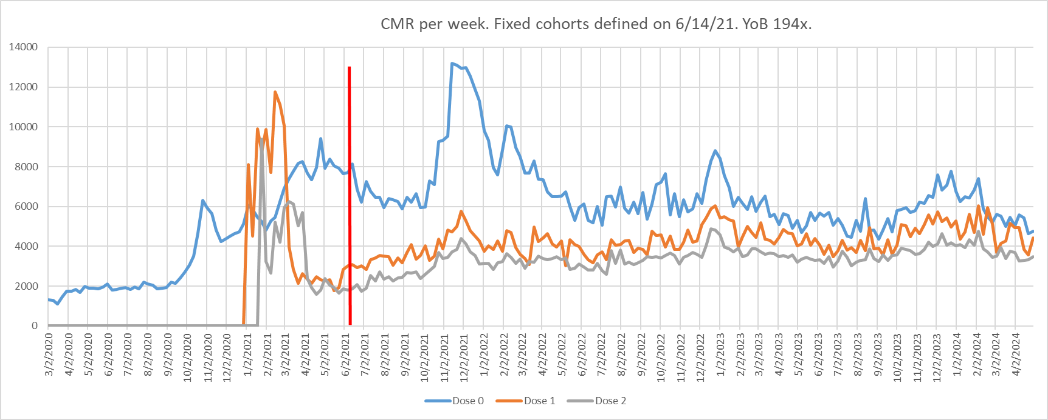

The COVID vax “benefit” was caused by the static HVE selection bias + NPH
Let’s continue with the same spreadsheet tab as we used in the previous section.

It shows that COVID mortality rose 2X from the non-COVID baseline (measured at enrollment) for the vaccinated (from 2000 to 4000) and by 2.15X (from 6,000 to 12,941) for the unvaccinated measured from the same baseline mortality time point.

While this may seem to be a 7.5% benefit for the vaccinated, this is not the case once we factor in the NPH effect.

Given r=3 and α≈0.163, if the vaccinated rose 2.0×, the unvaccinated are expected to rise 2.0×3^{0.163≈}≈2.39×
But the unvaccinated increase during COVID was only 2.15 which is < the expected 2.39X.

That means there was no mortality protection at all for the vaccinated.

The vaccine all-cause mortality “benefit” during the Omicron wave was a statistical mirage created by selection bias (the static HVE effect) and non-proportional hazards.

Bottom line: the data shows that the COVID vaccine didn’t save any lives because the ACM ratios of the cohorts during the most important large COVID wave were proportional to the baseline hazards of the cohorts (modulo the NPH factor).

There was no cherry picking or hunting for this example. I had pre-specified the 1940 cohort well and enrollment date before I did this analysis.

It only takes one counter example like this to falsify the 10X mortality benefit claim. The data wasn’t even close to a benefit. It simply doesn’t work for the 1940 cohort. We’re done. Full details here.

This shouldn’t be a surprise to anyone. This is why we never saw any “bends” in the COVID mortality curves in any country after the vaccines rolled out. This is also why Omicron was a non issue in low vaccine countries but a measurable one elsewhere including places that had high vaccination rates before any COVID arrived.

We can use a completely different method to get the same NPH result
We showed above that COVID mortality scaled super-linearly with your baseline mortality. The unvaccinated had higher COVID mortality simply because they had much higher BASELINE mortality.

So the COVID mortality benefit for a given age was simply due to the higher mortality/frailty of the unvaccinated cohort.

But there is an independent way we can demonstrate this effect more directly than mathematically.

Suppose we constructed two cohorts, one vaxxed, the other unvaxxed, but they had the same mortality and frailty because we used different age mixes or DCCI constraints to equalize the cohorts.

What happens is their vaccination status is immaterial with respect to their mortality during COVID vs. non-COVID.

In this section, we’ll show the same effect, but in the opposite way. We’ll show cohorts with the same mortality and frailty had the same mortality increase during COVID irrespective of their vaccination status.

If you observe mortality-matched cohorts as we do in the chart below, the ACM mortality differential between cohorts during high COVID completely disappears!

Most hazards are proportional. COVID is a rare exception. This is why, if you want to get an accurate assessment of VEdeath, you must compare v v. u cohorts with the same mortality and frailty; age is irrelevant.

To compare two cohorts, using time-varying ASMR cohorts is precisely the wrong approach. For COVID vaccine studies, to do a fair comparison, you must use FIXED cohorts, match mortality and frailty of the cohorts, and ignore age entirely.

It is easy to show that if we match mortality and frailty during non-COVID, the ACM rise tracks precisely during COVID regardless of vaccination status. This is extremely unlikely if the vaccines provide a 10x benefit. Source: KCOR_CMR_analysis: 2021-24 CMR matched DCCI>0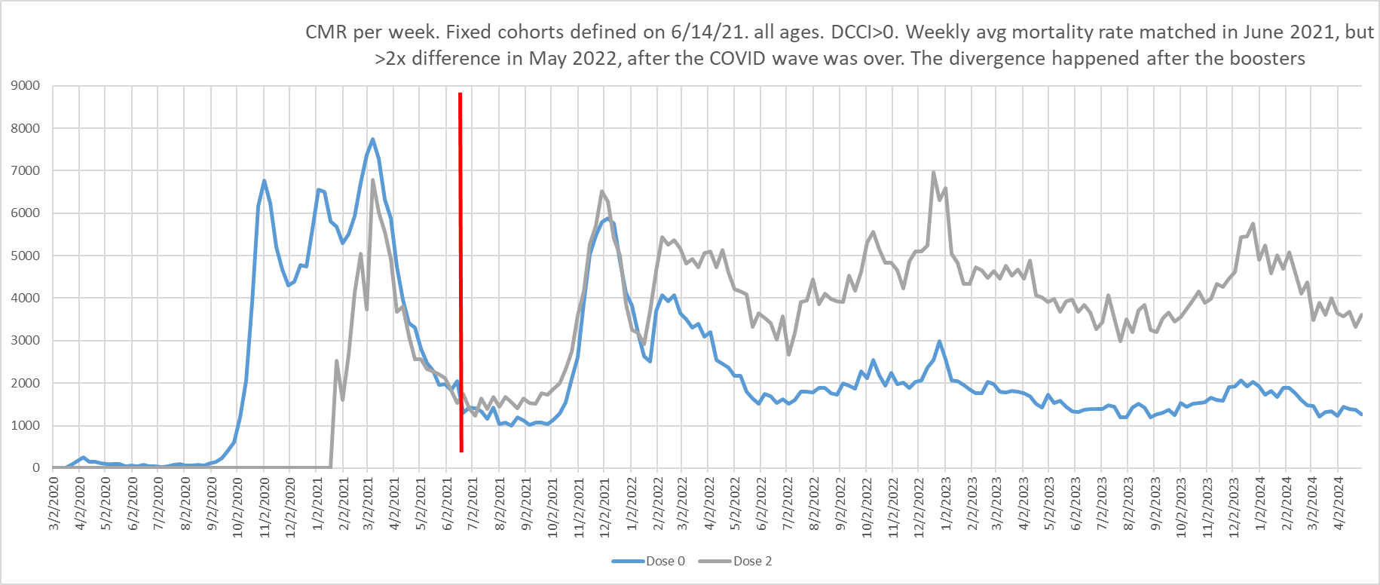

Here’s a second example of CMR matched cohorts showing they matched during COVID and non-COVID periods (from the CMR matched tab of the same spreadsheet):
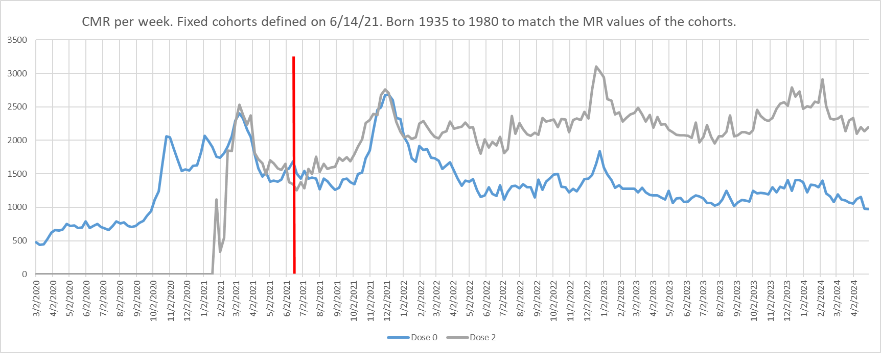
As you can see, cohorts with the same baseline mortality and frailty had the same ACM increases during COVID waves REGARDLESS of vaccination status!
In other words, it wasn’t the vaccine causing their immunity to COVID; it was their underlying health status.

Population level data confirms the lack of efficacy
There’s another way to confirm our hypothesis that the vaccine didn’t work: the COVID mortality peaks didn’t go down hardly at all in the POPULATION after the shots rolled out.

If you deploy a 10X mortality effective vaccine to 90% of the susceptible people, you should see an 80% drop from previous mortality levels during a COVID wave if the waves are comparable. If it works, you’re going to see a HUGE impact.

That impact just never materialized. The whole population measure (which eliminates selection bias confounding) shows pretty much no benefit.

See KCOR_CMR_analysis: “whole population no benefit” tab and you see the mortality rate peaks of the FULL population (regardless of vaccination status) after the vaccine rollout are similar to pre-vaccine peaks. This is NOT what you expect to see from a vaccine with a 10x mortality benefit that was given to 90% of the susceptible population.

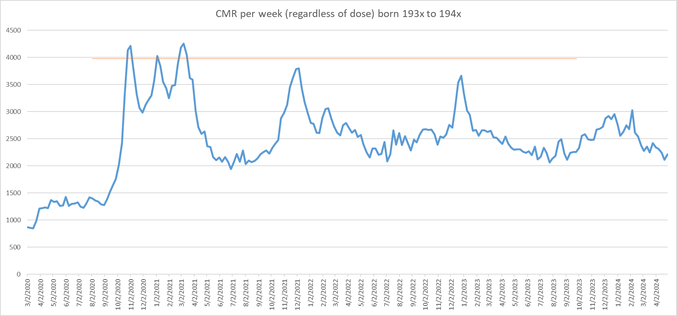

Vaccine harms
This dispenses with the vaccine benefit case; it was a mirage caused by HVE.

The rest of this document is focused on vaccine harms.

The most obvious vaccine harm signal in the world is the excess deaths in the Japan data
Japan—the most highly dosed country in the world—showed a large, sustained, multi-year national excess mortality rise beginning post-rollout. While ecological, this population signal is consistent with the cohort-level findings above

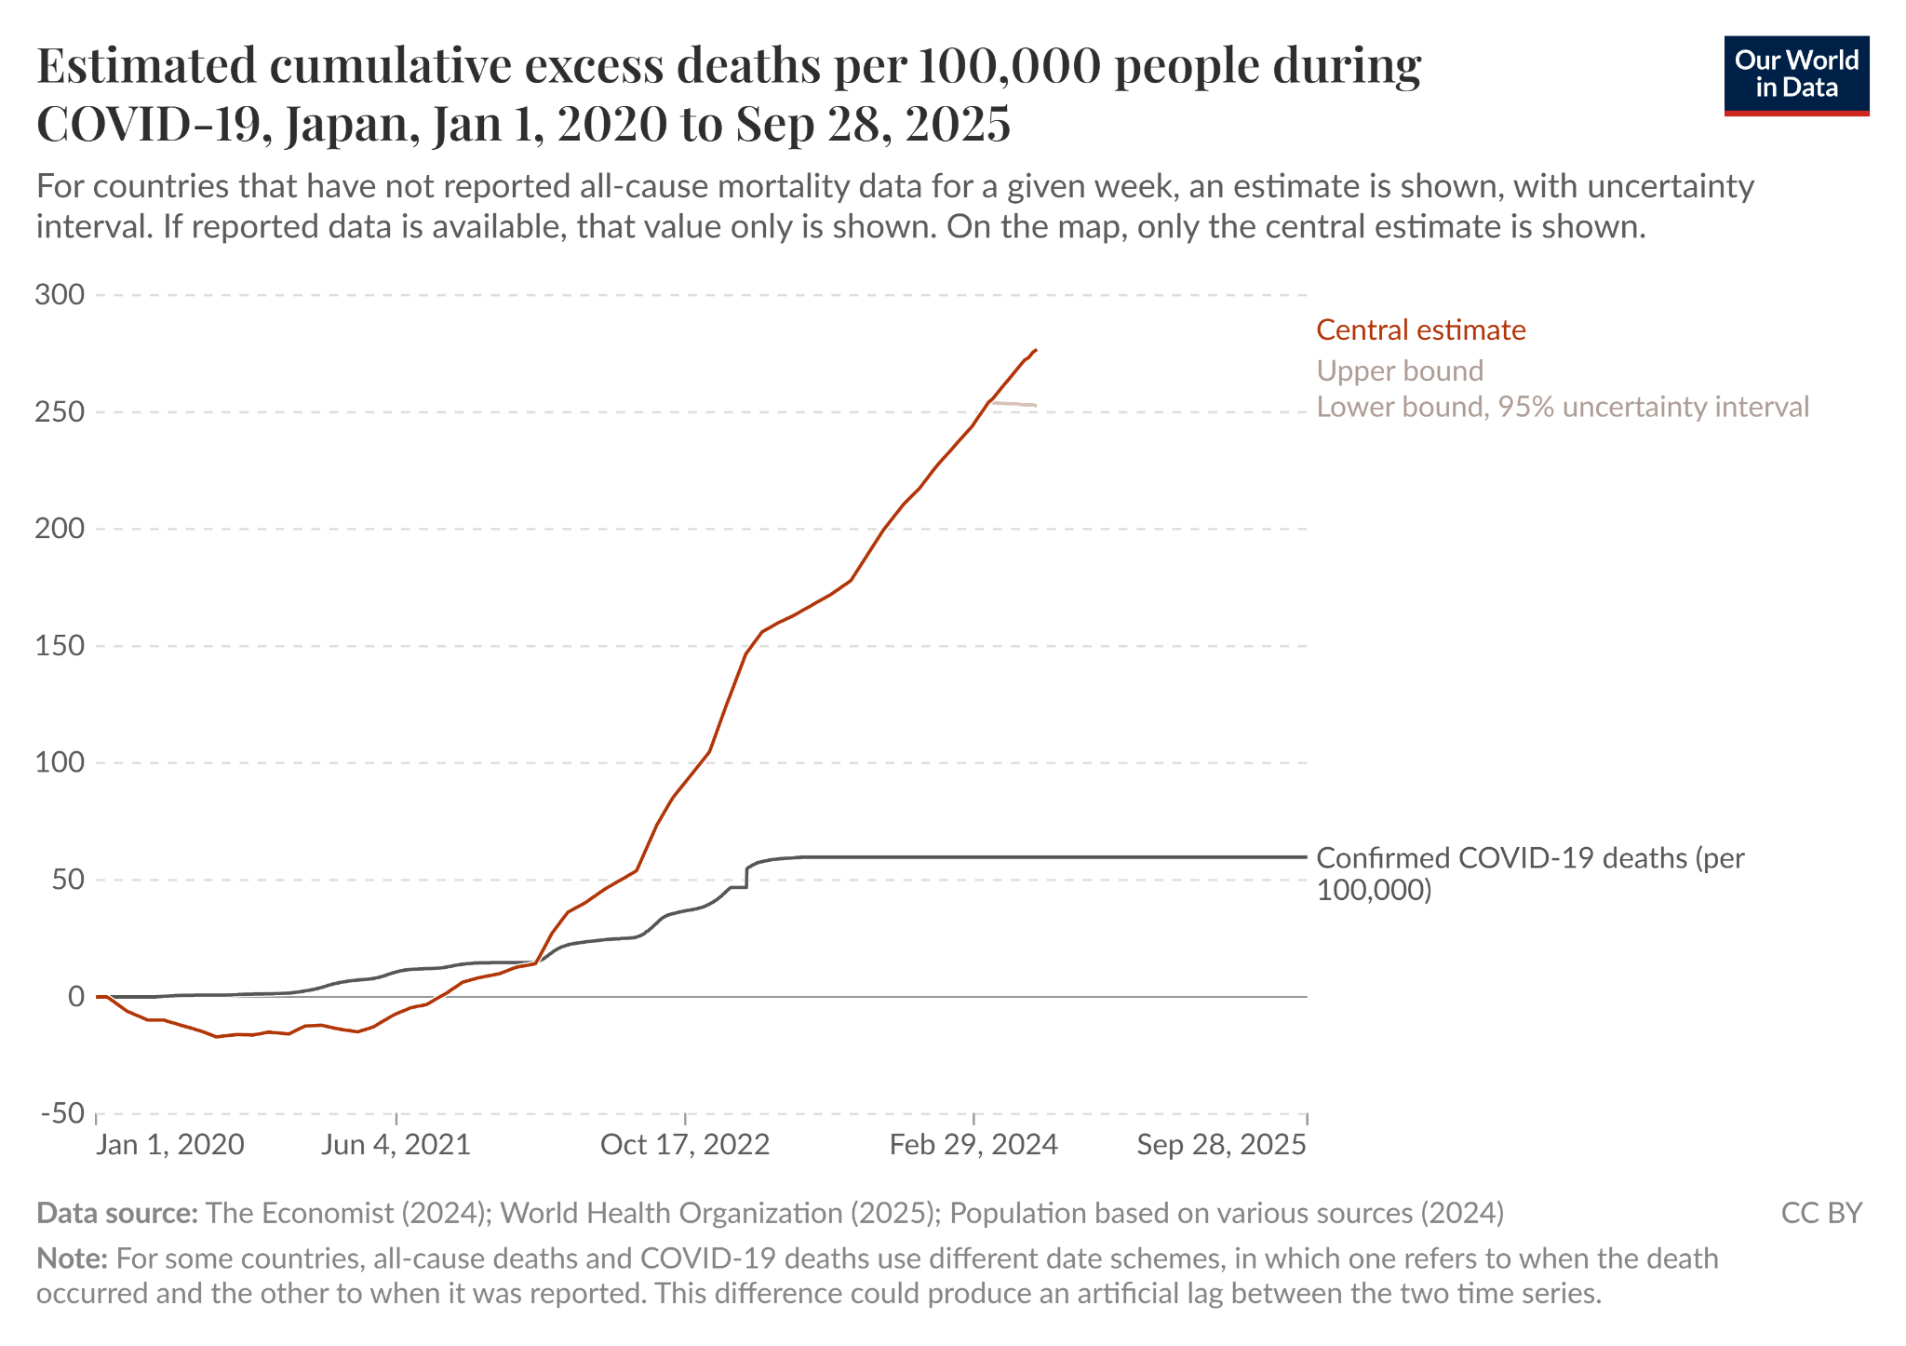

Here’s Australia. Same thing. Even after COVID flattened, excess death KEPT RISING.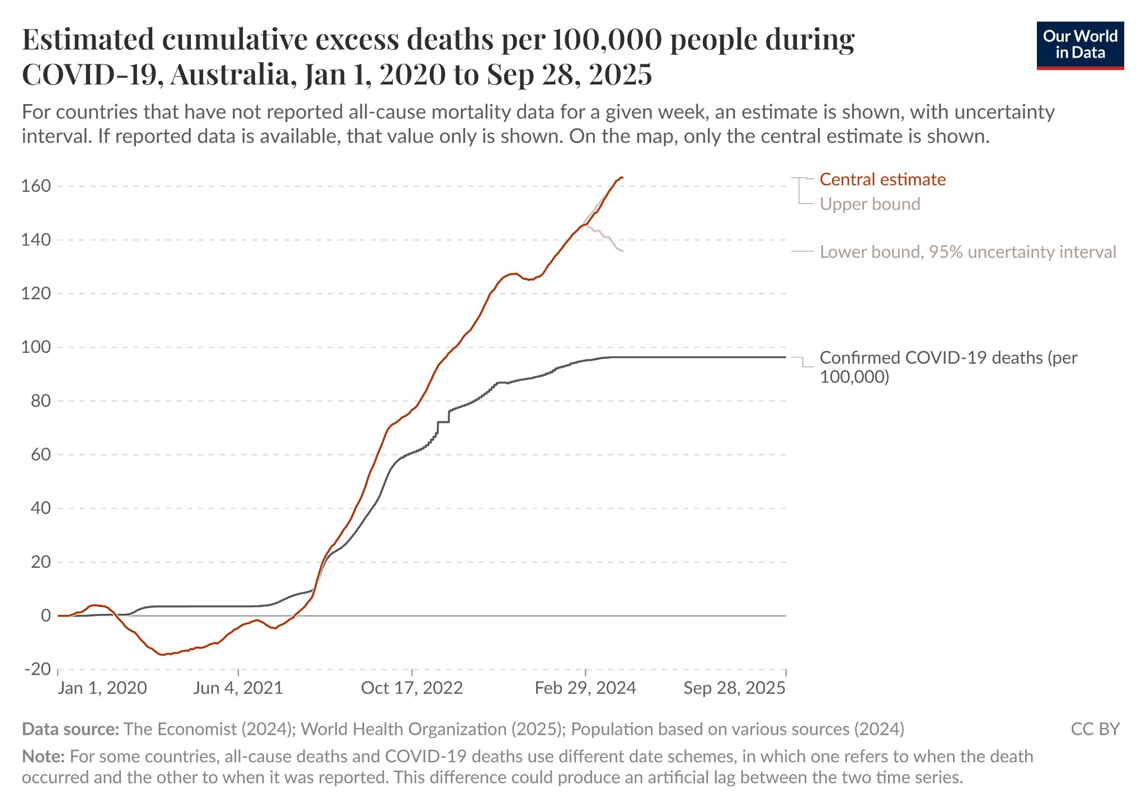

The US had over a 100% increase in mortality among our healthiest WORKING age group when corporate vaccine mandates rolled out. It was not COVID. Nobody has been able to explain what caused this and it wasn’t COVID: See Red values. From SOA report.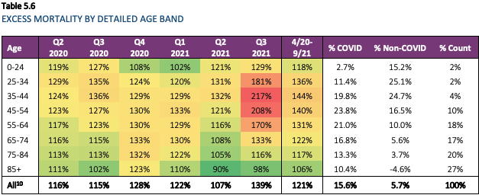

KCOR is the best way to measure net mortality impact when all you have is retrospective record-level observational data of mortality before and after vaccine rollout
There isn’t anything better than I’m aware of. If there is, I’m happy to evaluate the method. Please let me know.

KCOR is the only method with slope normalization which is required due to the significant HVE effects causing the creation of cohorts with non-standard h(t) slope.

AFAIK, you will not be able to analyze the Czech data with any other method and get reliable results.

KCOR method description
KCOR is a method to assess net harm/benefit when you only have data on birth, death, and dates of vaccination. The output is KCOR(t) which for any point t summarizes the net harm/benefit of a cohort relative to another cohort, e.g., Dose 2 vs. Dose 0. KCOR(t) Values >1 mean cumulative net harm.

The graph below which shows Dose 2/Dose 0 and Dose 1/Dose 0 shows that the vaccines cause a relative increase in mortality that is nearly linearly dose dependent.

On the other hand, the benefit (the negative slope part) is the same shape and magnitude for Dose 1 vs. Dose 2 cohorts which means the “benefit” is independent of dose. That would be consistent with a vaccine whose benefit comes from selection bias and not the drug itself.

At the end of the day, we can clearly see that those who got 2 shots had a higher mortality increase than those who got one shot.

So the data is consistent with harm >> benefit and for both doses the differences were statistically significant. This is for 2021-24 enrollment and shows for 194x cohort: Dose 1 v 0 and Dose 2 vs 0 (source: KCOR_sample computation).

The KCOR shows harms start after vaccination, there is a false vaccine benefit during Omicron, and then we return to the elevated mortality rate established shortly post-vaccine.
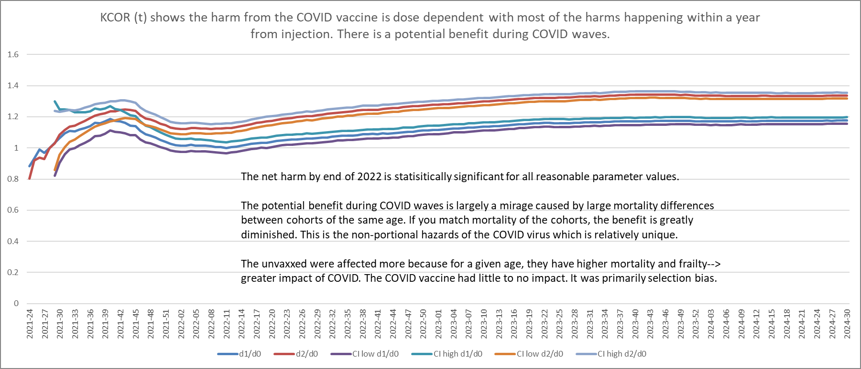

Process:
- Choose an enrollment date after most are vaccinated and right before a “no/low COVID period”
- Enroll people in cohorts based on # of vaccine they received by the enrollment date
- Track the alive/death count for each cohort each week
- Convert to a hazard rate using -ln(1-mr)
- Slope normalize the hazards for each cohort by fitting an exponential through the mean of two 12 week long “low COVID” windows chosen to be around 1 year apart
Exponential slope= ln(mean2)-ln(mean1)/(weeks between window center points)
- Use that slope s computed for each cohort to adjust each hazard value: adj_hr= raw_hr*exp(-st) where t=number of weeks from enrollment.
- Compute cumulative adjusted hazards per cohort by cumulating the hazards
- Divide the cumulative cohorts of interest, e.g. Dose 2 CH/ Dose 0 CH
- Normalize to the value of the ratio after 4 weeks.
- Compute the CIs using
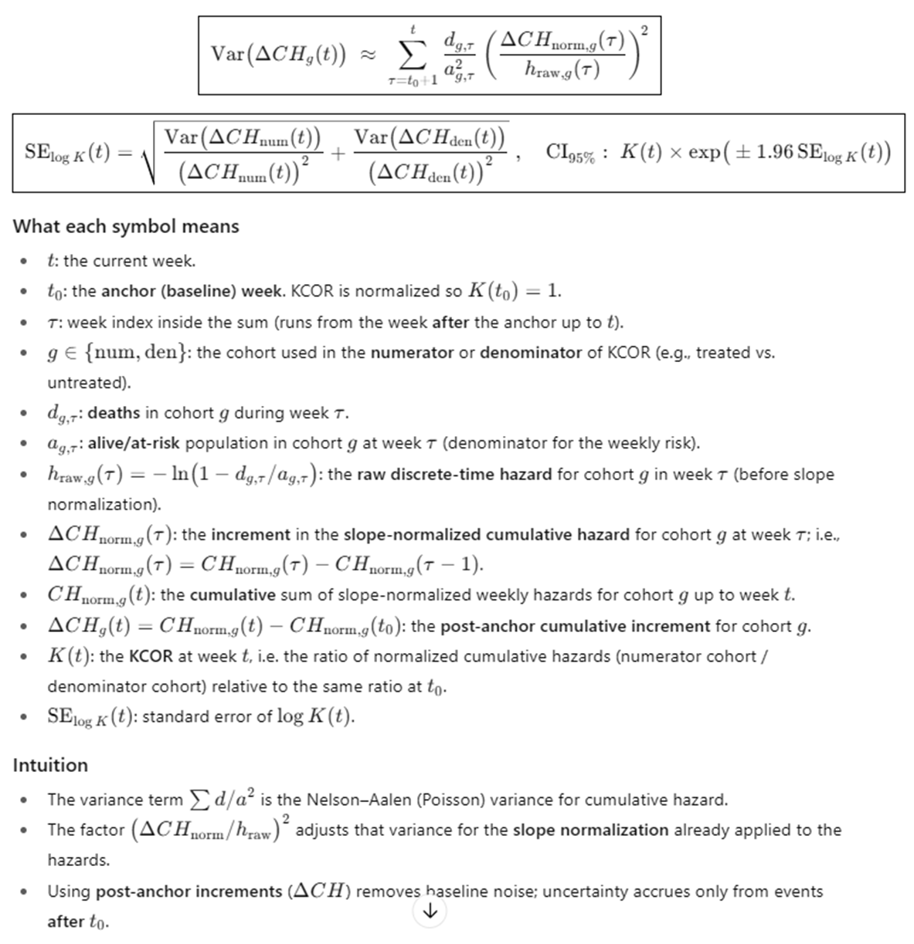
All of these steps are shown clearly in the example KCOR spreadsheet which was also used to produce the graph above.

KCOR assumes proportionality after slope-neutralization; the independent NPH estimate (α) is not used in KCOR which makes the vaccine appear much safer than it really is.

To falsify KCOR’s result on the Czech you must do at least one of the following:
  - Identify a flaw in the method itself
  - Show a key assumption was violated for those <90
  - Show you can show a statistically significant benefit most ages between 50 and 80 by choosing parameters within the guidelines
  - Identify a computation mistake in the implementation
  - Show that the Czech data is unusable
  - Show the correct interpretation of the KCOR curve (e.g., claiming the baseline should be chosen at the end of the quiet period)

KCOR numerical results show net harm for all ages and doses
There is an ASMR method that combines the net impact on a population. As you can see, it is statistically significant net harm for all doses, even with the false credit for the COVID shots working.

You can see the full KCOR results for all enrollments and all comparisons with 95% CIs here.

Here’s the summary for the age standardized cohort for the net impact as of end of 2022 which is the date specified for the contest (except for Dose 4):

Dose | Net impact | Enrollment date | Notes
1 | 1.0278 [1.012, 1.044] | 2021-24 | False COVID benefit or would be higher
2 | 1.1080 [1.095, 1.121] | 2021-24 | Same as above
3 | 1.4225 [1.398, 1.447] | 2022-06 | Booster shots didn’t get the false COVID benefit so you can see the harm more easily
4 | 1.2678 [1.241, 1.296] | 2022-47 | Jan 1, 2024 reporting date for net impact

Two things to keep in mind:

- Enrollment date matters. If you want to see the impact of Dose N, you pick an enrollment date shortly after Dose N. If the date is too early, e.g., right after Dose 2 rollout, you’ll find that the Dose 1 and 2 curves will merge because most Dose 1 will get Dose 2. If the date is too late, you’ll miss the “deaths post shot” harm for most of the doses.
- KCOR assumes proportional hazards. So KCOR gives FALSE CREDIT to the vaccine benefit because it assumes hazards are proportional. So it adjusts just fine to static HVE, but it does NOT compensate for the NPH effects so it gives the vaccine a false benefit, pushing down the actual harm. As we learned above, these shots were all harm.

Note that KCOR fully credited the vaccine for reducing mortality even though we showed above it was a mirage because if you want to compare vaccinated and unvaccinated cohorts, you should never do it based on AGE; you should do it based on SAME mortality AND frailty. KCOR assumes proportional hazards so the 20% NPH factor that KCOR didn’t know about causes the vaccine to look more beneficial than it really was.

In other words, reality is FAR worse than these numbers indicate.

Parameters
KCOR_NORMALIZATION_WEEK = 4 (set baseline over 4 week sample after enrollment and HVE skip)
DYNAMIC_HVE_SKIP_WEEKS = 2 (minimize dynamic HVE effects)
SLOPE2_W1 = (2022-24, 2022-36)
SLOPE2_W2 = (2023-24, 2023-36)
SLOPE2_W3 = (2024-12, 2024-20)
SLOPE2_W4 = (2022-42, 2022-48) [fallback second window if W2 has no data]
SLOPE2 selection = W1/W2 unless enrollment_date > start(W1), then W2/W3

Results
Note KCOR_ns column (the final column after the CIs) is without slope normalization and is more accurate for cohorts born on/after 1950 when there is less heterogeneity of the cohorts due to less depletion effects.

You can see a clear pattern of harm. The values are the KCOR(t) values at the end of 2022.

Dose combination: 2 vs 0 [2021_13] (this is an EARLY enrollment date)
--------------------------------------------------
YoB | KCOR [95% CI] | KCOR_ns
--------------------------------------------------
ASMR (direct) | 1.3358 [1.313, 1.359] | -
1920 | 1.1200 [1.083, 1.159] | 1.3883
1930 | 1.4946 [1.467, 1.523] | 1.6654
1940 | 1.4721 [1.431, 1.514] | 1.5763
1950 | 1.0088 [0.953, 1.068] | 1.1043
1960 | 1.6950 [1.534, 1.873] | 1.3283
1970 | 1.3068 [1.108, 1.542] | 1.1240
1980 | 0.6017 [0.458, 0.790] | 0.6932
1990 | 1.1353 [0.806, 1.600] | 1.1991
2000 | 3.1873 [1.024, 9.916] | 3.2341 (
Dose combination: 2 vs 0 [2021_20] (this enrollment date is after many had Dose 2 and right before the no COVID period to get an accurate baseline)
--------------------------------------------------
YoB | KCOR [95% CI] | KCOR_ns
--------------------------------------------------
ASMR (direct) | 1.1574 [1.143, 1.172] | -
1920 | 0.8903 [0.859, 0.923] | 1.1117
1930 | 1.0551 [1.035, 1.076] | 1.2184
1940 | 1.2860 [1.260, 1.312] | 1.4975
1950 | 1.1820 [1.138, 1.228] | 1.1634
1960 | 1.3132 [1.224, 1.409] | 1.1654
1970 | 1.3205 [1.183, 1.473] | 1.0536
1980 | 2.3853 [1.979, 2.875] | 2.6280
1990 | 0.8195 [0.634, 1.060] | 0.7391
2000 | 1.9942 [1.015, 3.920] | 5.7812

Here are the KCOR curves for the booster shots (3 v 0 and 2 v 0)
This from KCOR_analysis: booster N v 0 ASMR.

This is really important because the top graph shows the third dose caused a huge mortality increase as compared to unvaccinated mortality. But the dose 2 group who are nearly 1 year past their shot date, had mortality tracking the unvaccinated because the mortality increase caused by the shots are long gone (see note above about Enrollment date matters).

These two charts are very important because they also falsify the “it was HVE” claim. If HVE caused selection bias, the deaths from the dose 3 group would have to show up as excess in the dose 2 group and these two plots would be mirror images of each other. They are anything but. One is flat, the other has a rise.

The reason why dose 2 v 0 is flat is due to the observation point. The shots increase mortality levels in the first

This means the rise in mortality is real and wasn’t created by selection bias.
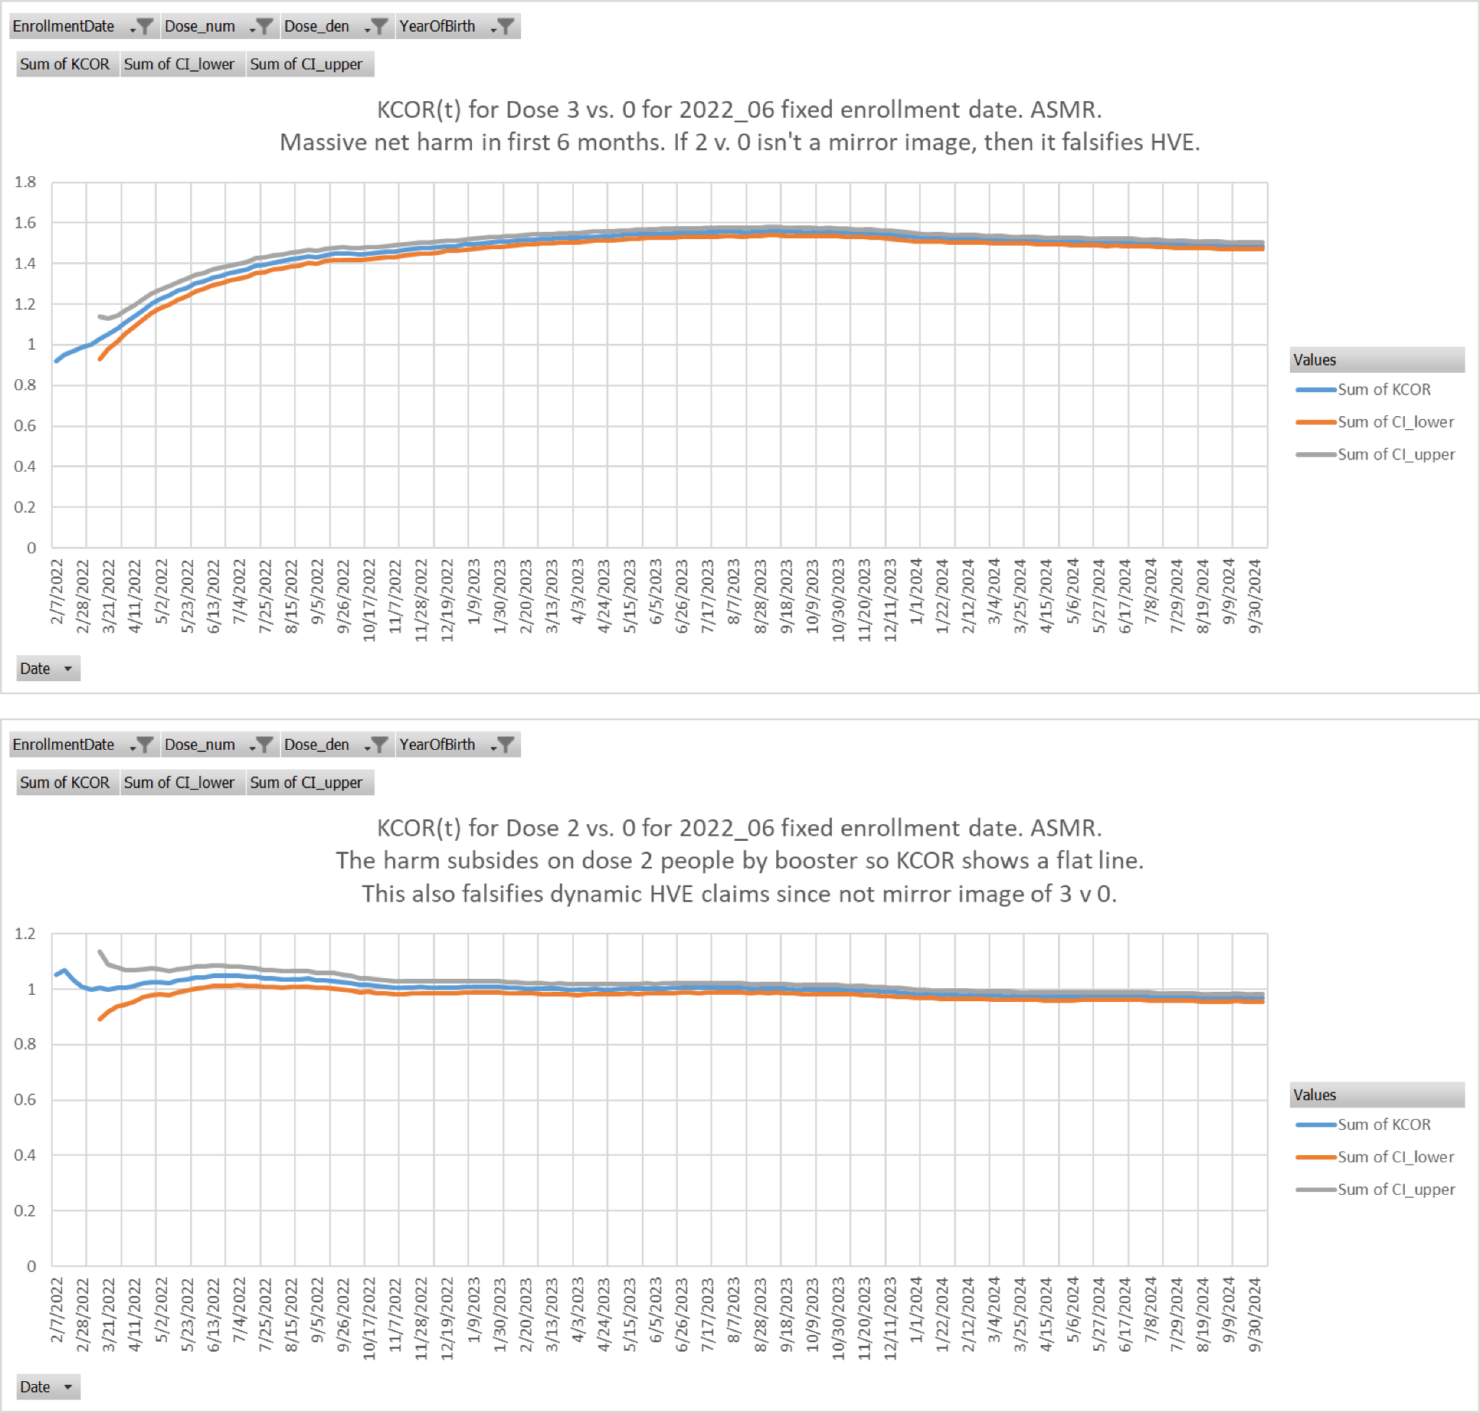

The event time-series data shows HVE<14 days and clear vaccine harm (two different ways)
Event-time plots (US Medicare daily; Czech weekly) where the x-axis is time since shot was given show dynamic HVE is exhausted after 14 days, just like it is for every vaccine in every country.

This is why KCOR skips 2 weeks post-enrollment to account for this effect.

Below is US Medicare. You can actually count the 14 dots.
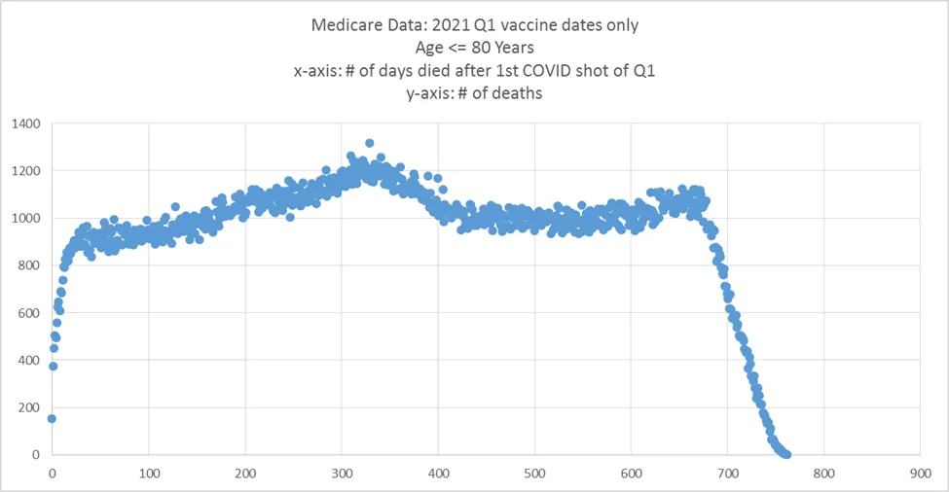

We see the same thing in the Czech data, but with the Czech data, it’s weekly resolution.

The graph below (from KCOR_ts_analysis: dose 1 and 2 on the same plot is very revealing.

This is a graph of adjusted h(t) where we applied the standard 8.5%/yr mortality adjustment so that a flat mortality would be a perfectly horizontal line. This is all ages, all vaccination months, but limited to Dose 2 and shows adjusted h(t) relative to the timing of the Dose 2 shot.

This one graph shows 3 different things:

- HVE lasted 14 days. Mortality stops increasing at week 3 (week 0 is shot week).
- Vaccine harm (elevated mortality on Dose 1 in early weeks). The red box highlights a huge mortality differential between shot 1 and shot 2. It’s not noise. It’s consistent between age cohorts. This is clear vaccine harm. Nobody ever noticed this. AFAIK, I’m the first person in the world to point this out.
- Vaccine harm (elevated baseline mortality). When HVE is over in 2 weeks, you are left with baseline mortality of the cohort under study. Here you can see mortality rises from that point, stays elevated, then falls later. If it wasn’t the vaccine what caused an elevated BASELINE mortality rate?
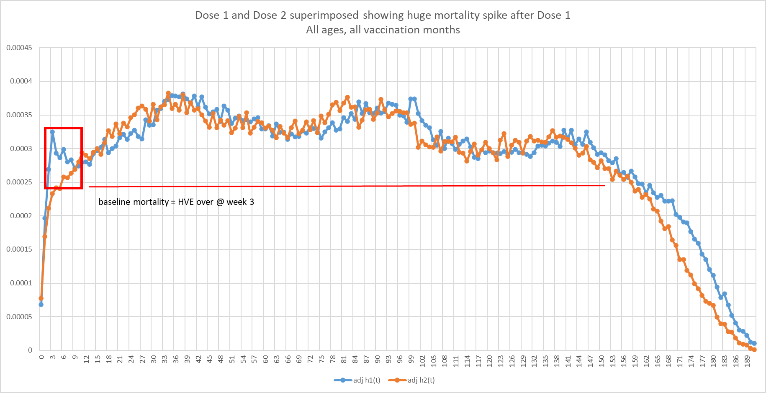

Many claim that HVE was extended in Czechia and the rise is just HVE. I falsified this in my Booster 3 v 0 compared to 2 v 0 plots above (they were not mirror images).

Here’s another plot from the same time series spreadsheet showing those vaccinated in Feb with Dose 2 had a perfectly flat mortality starting on week 3, when HVE ended, just as I claimed. It seems very old people (who were vaccinated in Feb) aren’t much affected by the COVID shots as you can see. Note their high h(t) values showing this really was the most elderly.
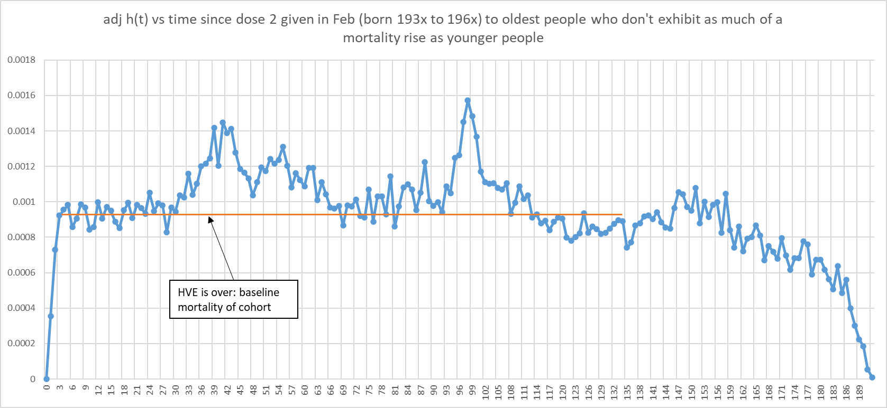

Dynamic HVE end test

There are 3 ways to tell when dynamic HVE is over:
- The slope of deaths/week discontinuously changes from “extreme” to “normal.” This is easier to see with daily data on an event time-series, but on a weekly event time series, the vertical gap between data points abruptly goes from “large and declining“ to “small and consistent” (and even negative).
- The absolute deaths/week number enters the “normal expected range” for the cohort (matches values seen later in the plot).
- You see a directional reversal

Any of these signals the end of HVE.

Both rules apply to the Medicare and Czech data shown above.

Here’s another example using calendar time plots with FIXED cohorts.:
From KCOR_sample_computation: 2021_24 enroll 1940. You can see by 2021-26, we hit normal levels for the unvaccinated as shown by the pointer.

That’s why we have a 2 week HVE parameter in KCOR because if we didn’t do that it would make the vaccine unfairly look bad.
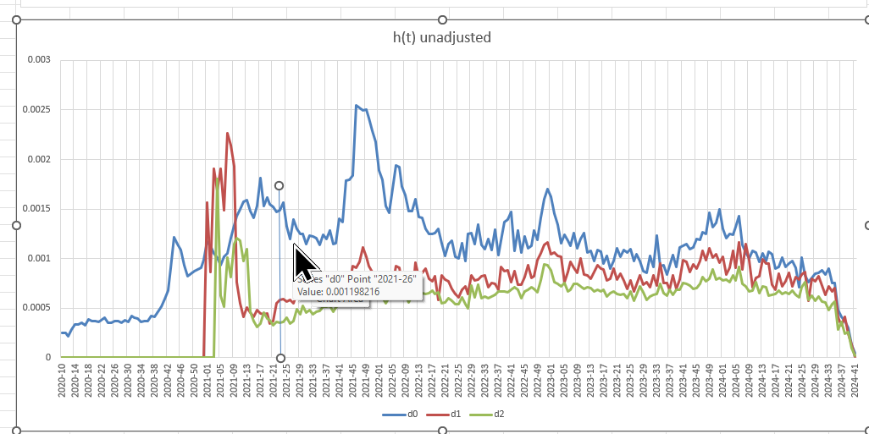

Other ways to validate vaccine harm

Qatar study: They did the most extreme 1:1 matching ever done in a study. The aHR for non-COVID death was >1 after 6 months, despite a HUGE (and clearly false) HVE benefit (we know the vaccines don’t reduce NCACM).
“In the first 6 months of follow-up in the two-dose analysis, the aHR was 0.35 (95% CI: 0.27–0.46); however, the combined analysis of all subsequent periods showed an aHR of 1.52 (95% CI: 1.19–1.94). In the first 6 months of follow-up in the three-dose analysis, the aHR was 0.31 (95% CI: 0.20–0.50); however, the combined analysis of all subsequent periods showed an aHR of 1.37 (95% CI: 1.02–1.85).”
Hungary study: Fig 1 and 2 are the smoking guns. These are KM plots. They reveal 3 huge red flags:
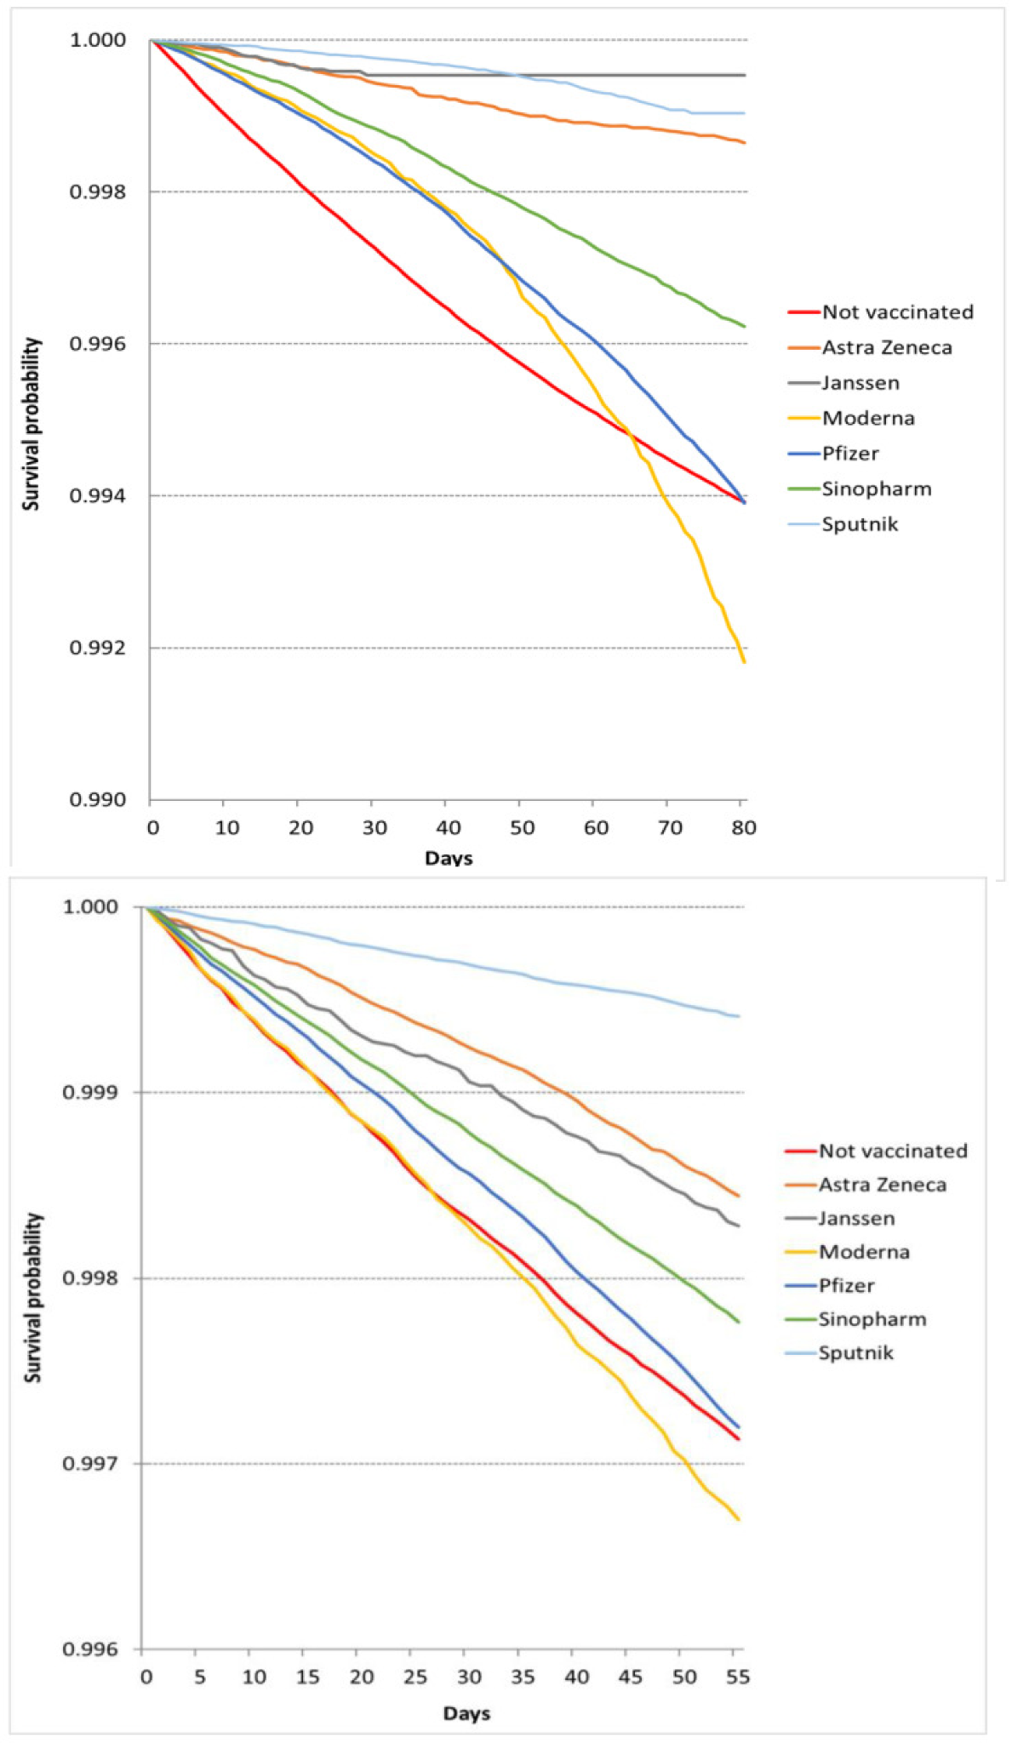
    - Moderna always had the worst survival despite having the healthiest cohort.
    - Moderna curve pathologically deviates downward
    - During both periods the Pfizer and unvaccinated curve match at the end. Having one match can just be a coincidence. Having them match in both periods means the vaccine provided no protection during COVID (and Moderna was even worse).

Summary
When selection bias (HVE) and non-proportional hazards are corrected, the apparent vaccine mortality benefit disappears; KCOR’s slope-normalized results show net harm dominates by end-2022 and the net harm is confirmed in other independent studies using independent datasets.

